We grouped the users dataframe in Pandas by 7 day time intervals and filtered off the users that had 3 or more visits on separate days (e.g. adopted users). Then we run a Random Forest model on the logins data to identify top features that can be used for predicting adoption.

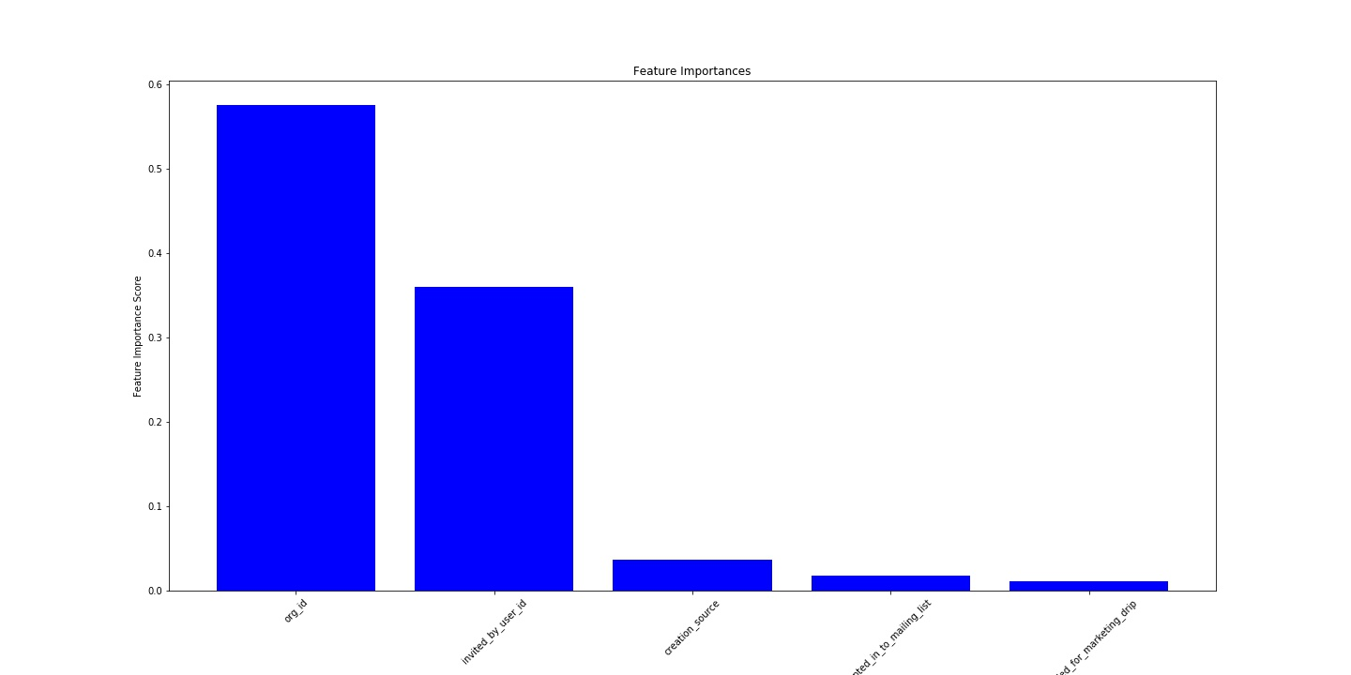

The top factors that predict the user adoption are the org_id for the organization that the user is joining and the user_id of the user who invited to join.